Y2Q2W3

Josiah

Ask: Have you ever done something and found out afterwards it was the wrong thing to do?

Ask: Did you still get on trouble for it?

Say: Back when God had saved the people of Israel from Egypt and made them His special people – He had promised them that IF they followed His instructions, then no one would be able to defeat them but if they didn't – then their enemies would come and destroy them.
Say: Last week we learnt about King Hezekiah, and the week before that we learnt about King Joash. Today we are learning about another of the Kings.

Bible Story

Sing Songs

Ask: Have you ever had dirt on your face and you didn't know until you looked in the mirror?
Say: The Bible is like a mirror. A mirror shows us what is wrong with our face. The Bible shows us what is wrong with our lives.

Return to tables
Memory Verse: Fill in the blanks and then say the memory verse on the colouring page.

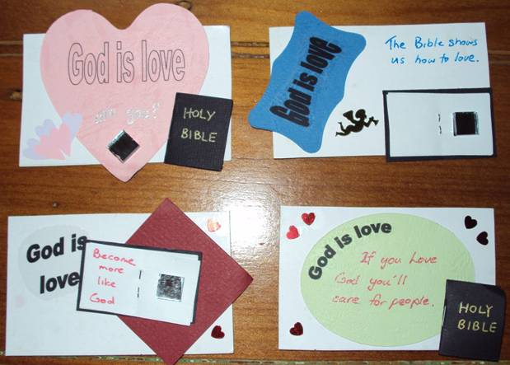
Say: This term we are going to make fridge magnets to tell the Bible stories with. You will keep your magnets in a special magnet book which we will loan to you until the end of the term and then you can take the magnets home – but we will keep the magnet books for next time. DO NOT DRAW OR WRITE ON THE MAGNET BOOKS

Craft – Fridge Magnets
- Start with a rectangle card and add a coloured shape.
- Add a God is love sticker, mini Bible and mirror etc.
- Add a magnet on the back.

Magnet Books
- If they were away last week: Choose a magnet book. Write your name on a label and loop through handle. Hand out king, crown, prophet and sun.

Discuss the following depending on age, interest and time:
Does it seem fair/unfair to get in trouble for something that you didn't know? (What if someone doesn't see a red light and drives through it and causes an accident?
Have people day forgotten about God's commands? – consider the different commandments…
The Bible specifically mentions Josiah removing the witches and mediums etc. What do we see of these types of people today? (See poster for more ideas)
Do you follow Gods commands?
When people look at you do they think that God is love?

Optional Craft: Say: Josiah cleared out all the witches, psychics and mediums; these things are still around today. Cut pictures or ads from magazines and paste them on the poster.

Finish with prayer.

